INTELLIGENT VEHICLE DAMAGE

ASSESSMENT & COST ESTIMATOR FOR

INSURANCE COMPANIES

LITERATURE SURVEY

Abstract:

Analysis of the damaged vehicle that can be automatically claiming insurance that takes human resource, time and effort. Image processing and machine learning techniques are analysing the vehicle damage in the proposed solution. In Advanced solution helps to speed up the claiming process sufficiently. Consider a situation, if a person is driving a car they met an accident the vehicle owner can take a few photos of the damaged car from a mobile phone that can be send to the insurance company and can just upload the photos to the system. The system can analyse the damage, severity of the damage as well as location of the damage. In this proposed project the insurance company can machine-driven the car damage analysis process without the need for humans to analyse the damage done to the car. Therefore, it is a very challenging task for quality of computer vision techniques and also Machine learning technologies

Keywords:

Car Damage Detection, Prediction, Deep Learning, CNN, VGG16.

I. INTRODUCTION:

In today's world, it can observe that the number of vehicles we use is quickly expanding; let's agree that there isn't a single street without a car. As a result, an increase in the number of automobiles on the road may lead to an increase in the percentage of accidents occurring nearby; additionally, the number of accidents occurring nearby would be significant; the accidents would not be particularly serious, but the automobile would be damaged, prompting people to file insurance claims.

The whole idea focuses on this question: how can a customer claim insurance more quickly? To keep the procedure quiet, a machine learning model is developed that utilizes image processing to categorize the photographs and calculate the percentage of damage to the car. The user will be able to get payment based on the model's outcomes. Because the ML model would be exclusively responsible for this procedure, it would be faster than the manual approach.

Analyse the damage in a fraction of the time it takes people and with minimal human interaction.

# II. LITERATURE SURVEY

In this literature survey several methods have been proposed for detection of car damage.

Srimal proposed a solution which uses 3D Computer Aided Design for the discernment of car damage from the picture, the system only detect damage at edge portion only. Detection of the car damage through CAD software requires some knowledge about the software.

S Gontscharov, the proposed system designed by using YOLO (you only look once) algorithm to detect the car damage, Here the multi sensor data fusion technique is allows to locate the portion of damage more accurately and performs detection faster compared to other algorithms which is fully automatic and doesn’t require much human intervention.

Phyu Mar Kyu, the proposed system uses deep learning based algorithm are VGG16 and VGG19 damaged car detection in the real world. This algorithm notice the severity of the damaged car based on the location. Finally the author concludes that L2 regularization work greater.

Girish N, the proposed system uses vehicle damage detection technique depends on transfer learning and mask RCNN, The mask regional convolution neural network determines a damaged car by its position and estimate the depth of the damage.

A Neela Madheswari, the proposed system uses convolution neural network is use to accept that image contains a car damage or not. It take as great opportunities to attempt by classifying the car damage into different classes

# III. PROPOSED METHODOLOGY

Detect the car damage using photo taken at the accident scene is very useful to reduce the cost of processing insurance claims, as well as provide greater convenience for vehicle users. The following methods are used in the proposed system.

1. Dataset Explanation.
2. Describing the level of damage.
3. CNN Model.
4. VGG16 Algorithm.

# 1 Dataset Explanation

Data preparation is very costly depending on the demand of marking the data.VGG16 can be used to need as a true image in an input. Cross-validation is an approximate for our models to takes a more time since, it is very costly to train the VGG16 for many years. Consequently split the dataset arbitrarily into distinct set for training and validation. Car is to train for multiple times. At the end train and test can be split for similar images. In this dataset we use more different types of car images. Report our three collected datasets are following.

* Image Net dataset – Vehicle
* Dataset - All the three dataset are contained train and validation of damaged and undamaged cars.

2. Describing the Level of Damage

Damaged car can be defined by their incidence. We think about each damaged part into small, average, severe. The categorization of the damaged car levels as follows.

* Small Damage - creaks in headlight.
* Average Damage - Damage in car doors.
* Severe Damage - damage of air bags.

# 3. CNN Model

CNN is one of the neural network it is used for processing the image and segmentation of the image. In this project we use a convolution neural network model for detect the image contains a car. CNN is also used to analyses the damage of the car.

# 4. VGG16 Algorithm

The Image Net Large Scale Visual Recognition Challenge is one of the visions of computer. They contain two jobs. Initial is to detect things within an image called object localization. Next is to classifying the images called image classification.

CNN is the one of the best vision model planning. In VGG16 contains four layers they are convolution, max pooling, and fully connected softmax. In this algorithm 16 refers to contain 16 layers.

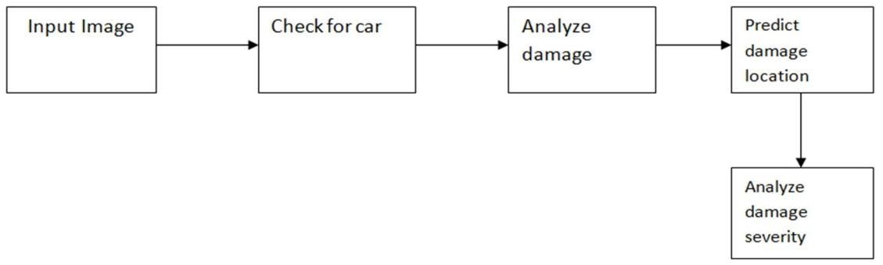

In this diagram they tell about the working of the project. In the first block they took a damaged car as an input. Once this image is given as an input after that they apply neural network is to be interesting for detecting the image hold the car. Car detection is done perfectly, then goes to the next step or else does not go to the next step. Detection of the car is done perfectly then analyse the damage of the car by applying the neural network. Check for car it may contains any damage then go to next step or does not proceed to the next step. If the damage is detect in the system estimate the location in the damaged car like front, back, and side of the car. They give the accurate result for the location of damaged car, and also give severity like minor, moderate, and severe. In this system they carry out some functions including car detection, car damage analysis, predict the location of the damaged car and also car damaged severity.

# IV. EXPERIMENTAL RESULTS

First we have to train the image contains a car. The data contains three classes namely train, test and validation. Trained image is compare with the test image. Car as to be trained for many times by using epochs which means how many times the algorithm can work between the whole training dataset. In this graph they can take only two times of running the algorithm. Finally the comparison is completed lastly print the graph containing accuracy, validation accuracy, loss and validation loss that is shown in the below fig.2 and fig.3.

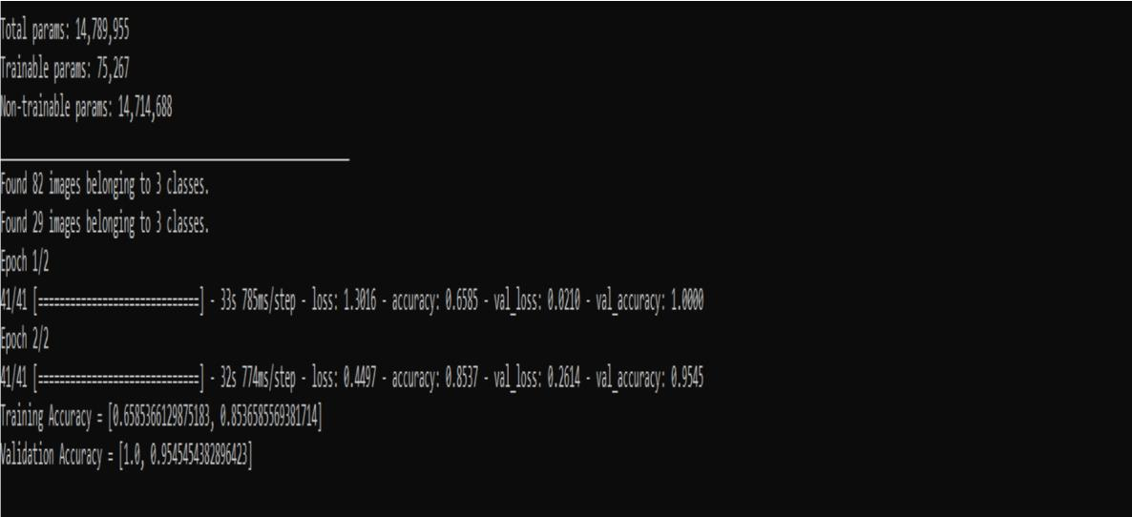

Fig. 2: Accuracy result of car

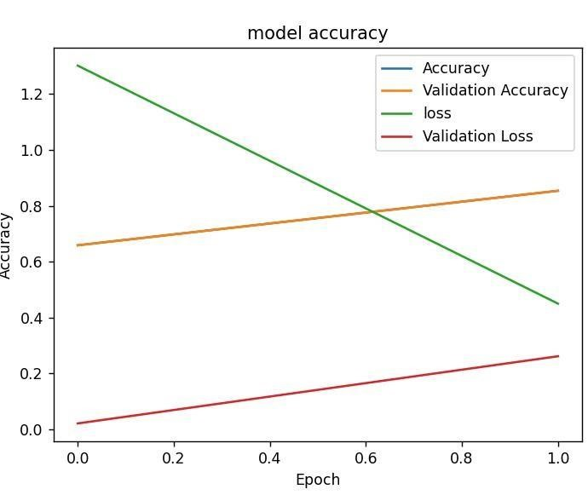

Fig. 3: Line graph of model accuracy

After that the system takes input as damaged car image. To identify the location and severity of the damage Input car is shown in the fig.4.

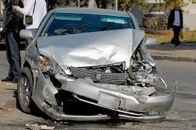

Fig. 4: Input image

Once the image is loaded then we check that image contains a car or not. If the image contains a car then print the validation this is a picture of your car otherwise, they does not print any result. Shown in the below diagram.

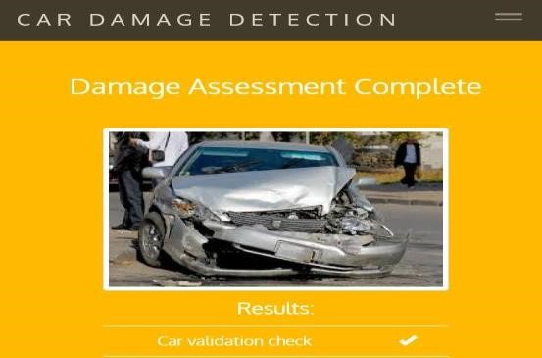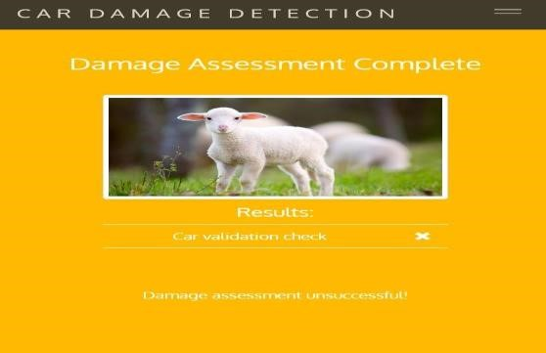

Fig. 5: Successful car validation Fig. 6: Unsuccessful validation

Next have to analyze the damage of the car. Car damage as to be analyze by applying the neural network and check for validation then print the damage validation check is true. That is show in below diagram.



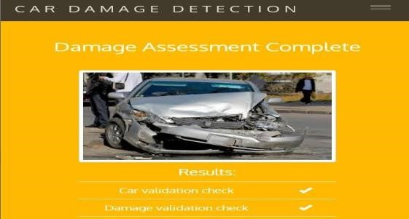

Fig. 7: Successful damage validation

Once the damage validation is check successfully then we have to predict the damage location such as front of the car, rear of the car and side of the car. Shown in the below diagram.



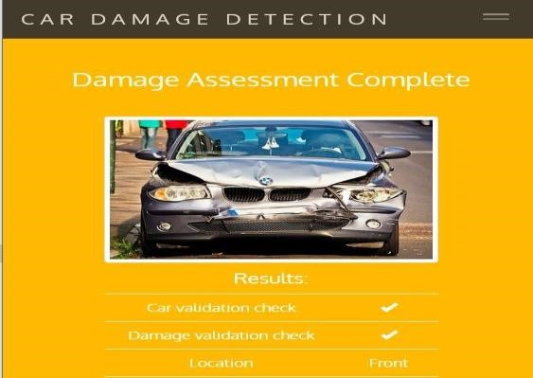

Fig. 8: Prediction of front location

After completing the location of the damage prediction then we have to check for severity of the damaged car namely minor, moderate or severe. Shown in the below diagram.

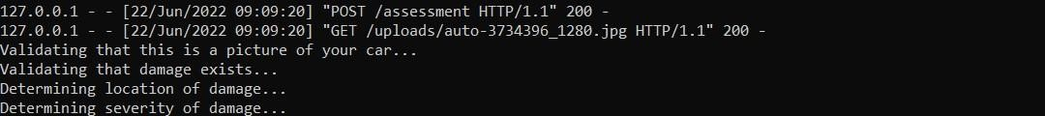

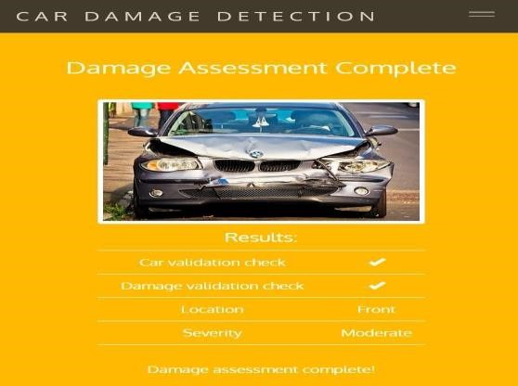

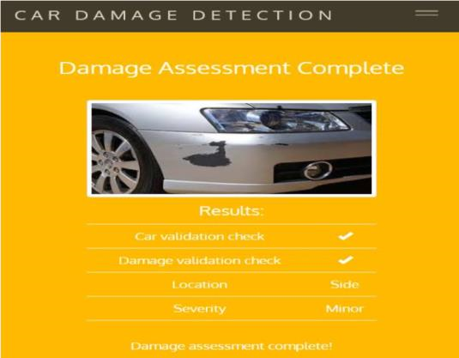

Fig. 9: Damage assessment complete in minor severity Fig. 10: Damage assessment complete in moderate severity

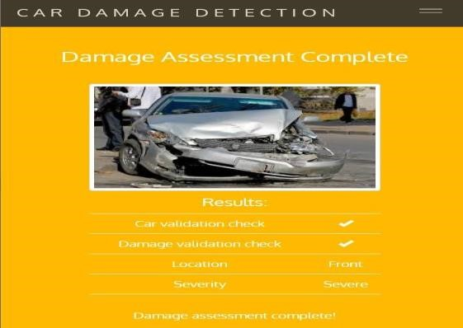

Fig. 11: Damage assessment complete in severe severity

# V. CONCLUSION

In this proposed project a neural network based solution for car detection; manage the problem of car damage analysis, prediction of car damage location and severity of the damage. This project carries out lot of functions in a one package. The system will definitely help the insurance companies to analyze the car damage a lot more successful and well organized. Simply by send the image of the car, the system will analyze the given image and show if there is any kind of damage to the car along with the location of the damage and also the severity of the damage.

# REFERENCES

[1]. A.Neela Madheswari, J.haripriya, G.Kiruthika, R.M.Meyammai Mahendra Engineering college, India,exterior vehicular damage detection using deep learning, department of computer science and engineering.

[2]. Girish N, Mohammed Aqeel Arshad, car damage detection using machine learning. International journal of advances research in computer and communication engineering, Vol. 10, issue 8, August 2021 DOI 10.17148/IJARCCE.2021.10808.

[3]. Phyu Mar Kyu ,car damage detection and classification, faculty of information technology king Mongkut’s institute of technology ladkrabang Bangkok, Thailand 62606003@kmitl.ac.in.

[4]. S. Jayawardena, Image based automatic vehicle damage detection. PhD thesis, College of Engineering and Computer Science (CECS), 12 2013.

[5]. S. Gontscharov, H Baumgartel, A.Kneifel, and K.-L. Krieger, Algorithm development for minor damage identification in vehicle bodies using adaptive sensor data processing," Procedia Technology, vol. 15, pp. 586 {594, 2014. 2nd International Conference on

System-Integrated Intelligence: Challenges for Product and Production Engineering.

[6]. Y.-J. Cha, J. Chen, and O. B’’uy’’uk’’ozt’’urk, Output-only computer vision based damage detection using phase-based optical flow and unscented kalman _lters," Engineering Structures, vol. 132, pp. 300, {313, 2017